**COFFEE DATA ANALYSIS**

1. According to my analysis for Coffee data set it was found that the Consumption of Colombian coffee is more which leads to higher profit and sales rate.

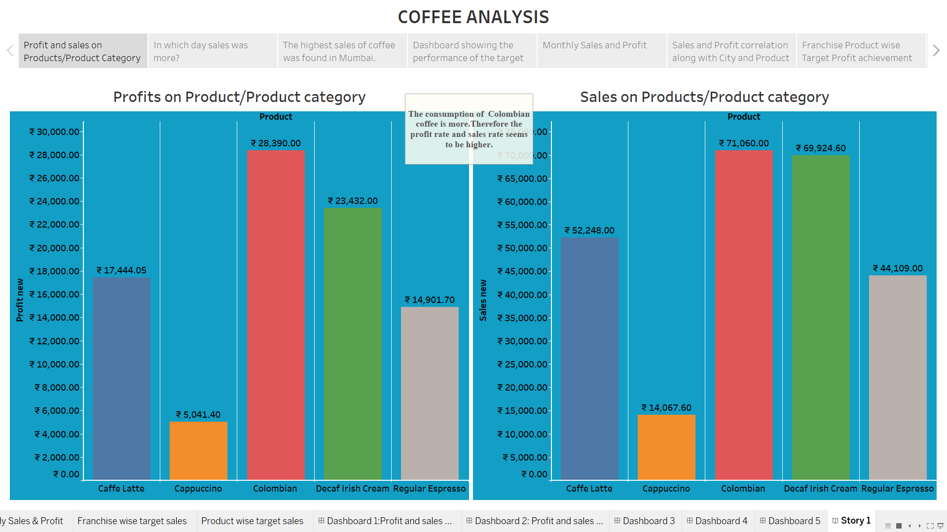

1. If I check the rate of sales according to the city wise it was found that Colombian coffee has the highest sales rate in Mumbai compared to other metropolitan cities. As Mumbai is the largest metropolitan city, the consumption of coffee is more maybe due to people tend to work more.

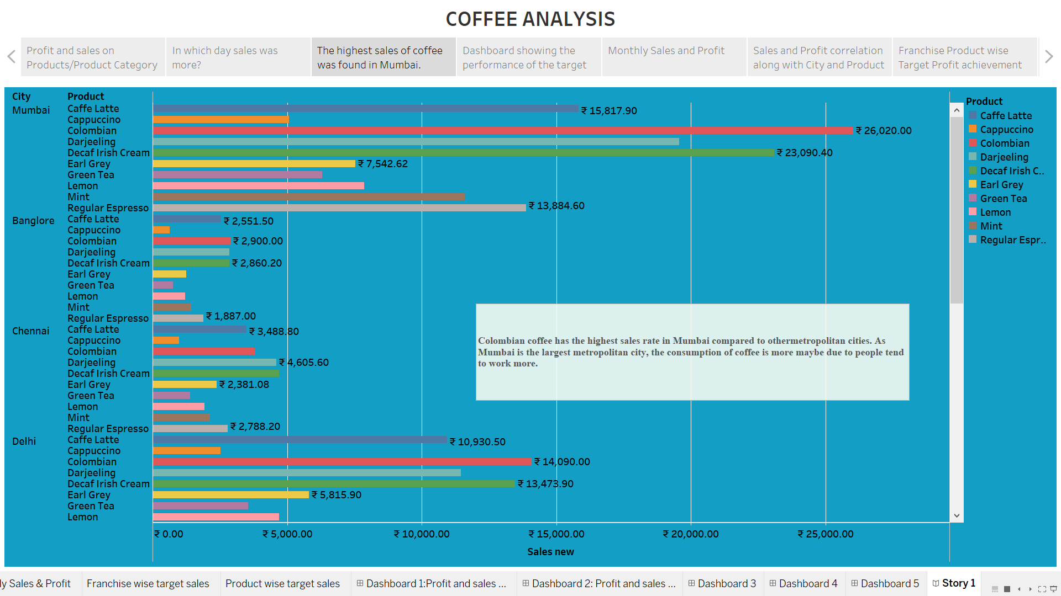

1. In Month of August the sales of coffee were higher in Mumbai city by ₹ 12,500.86

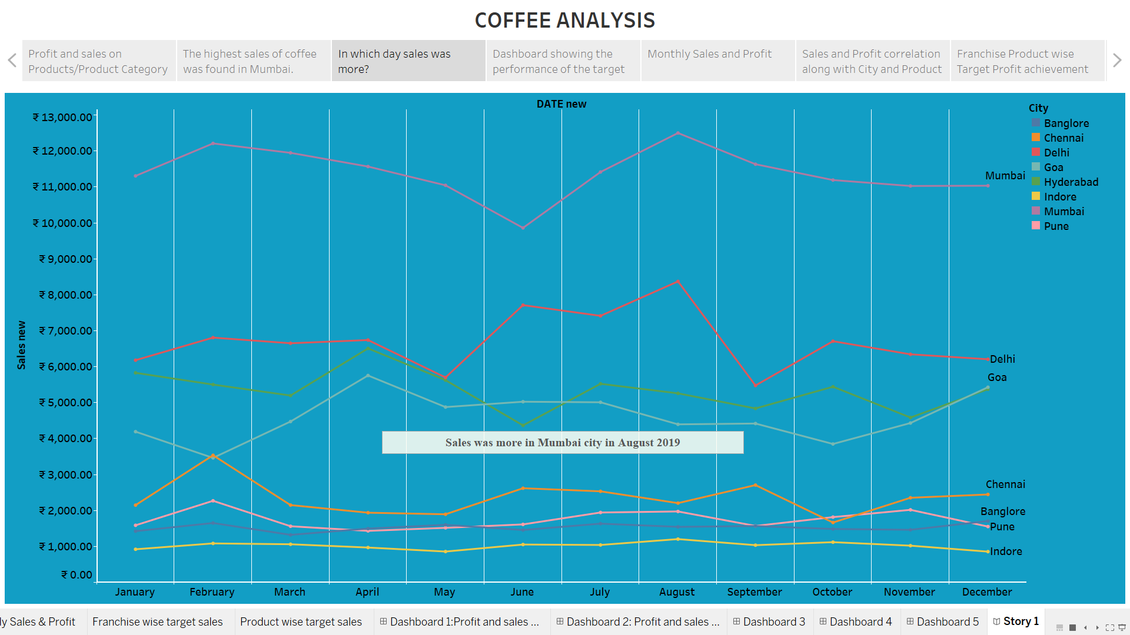

1. A dashboard was created showing the performance of the target sales and target profit based on the product. As per the analysis the Profit was lesser than the target Profit. And the Sales rate was increased by the target Sales. It seems that Colombian coffee is preferred more wrt to other coffee products.

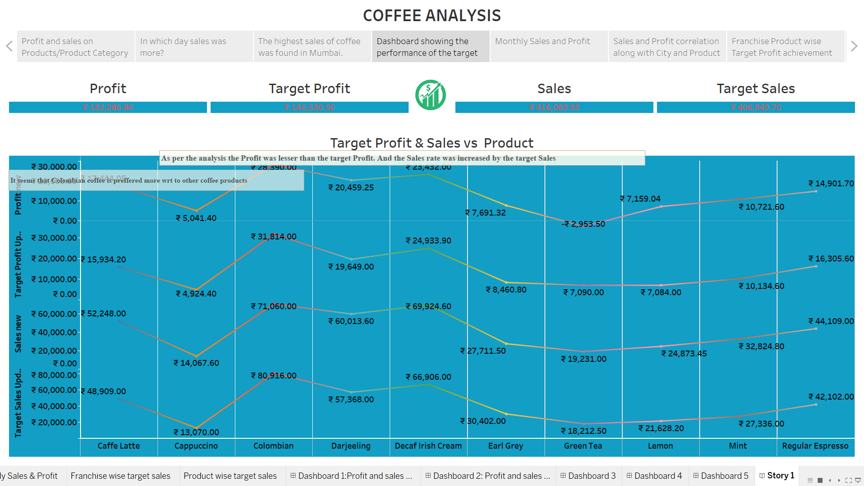

1. This the monthly sales and Profit chart it was seen that that hightest sales of ₹ 36,525.62 was in February month with a profit of ₹ 12,069.39 in August.

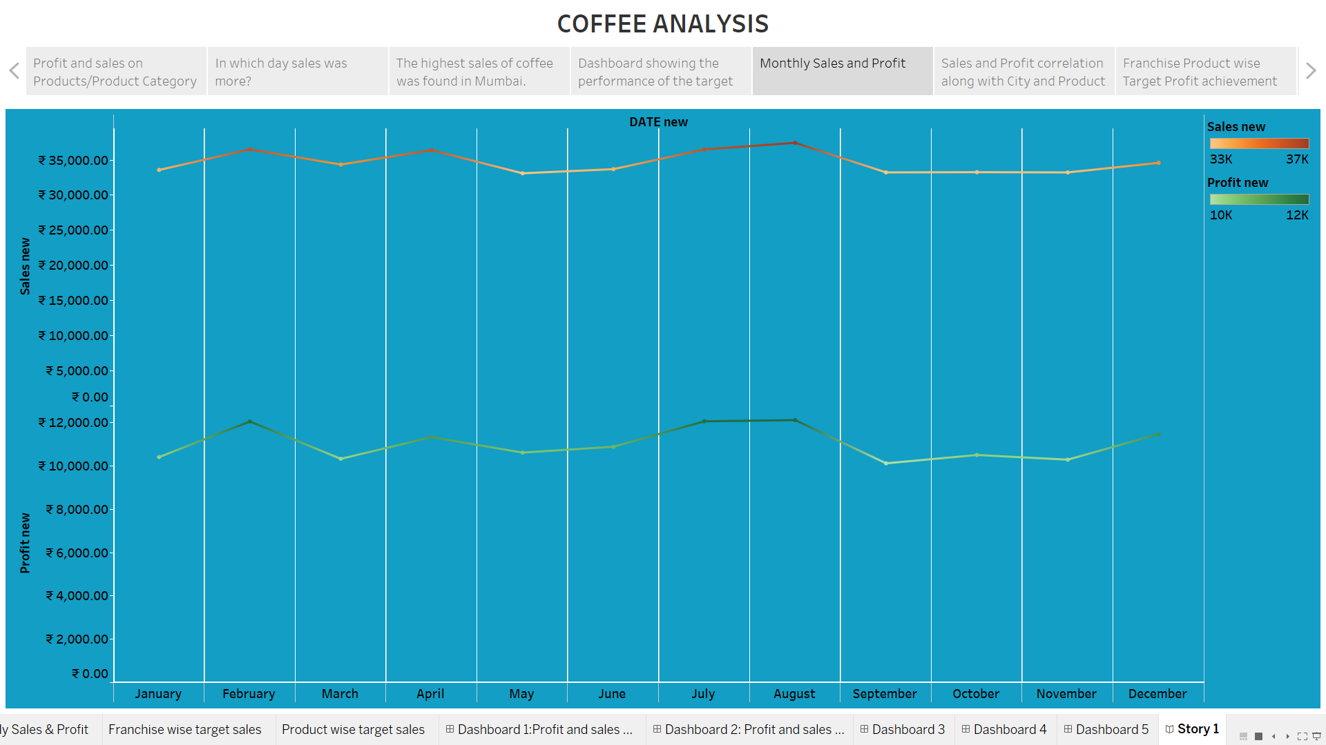

6.The below chart represents Sales and Profit correlation along with city wise Sales and Profit.

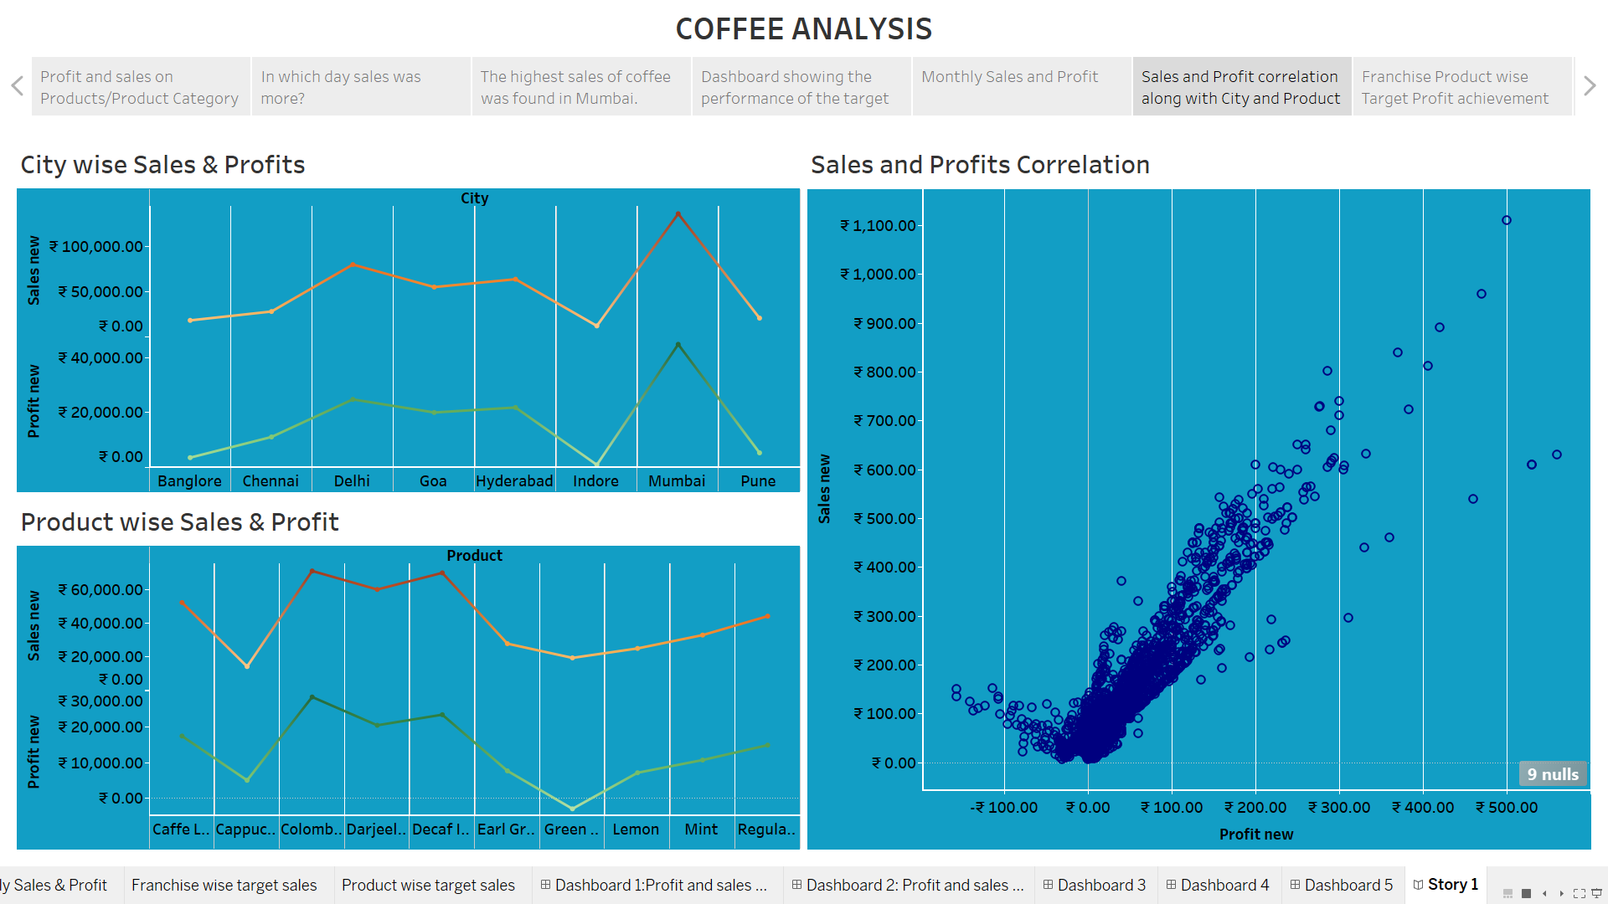

1. In Franchise wise Target Profit achievement it was seen that the Prfit target wasn’t achieved by any of the franchise. And in Product wise Target Profit achievement green tea was found to be in loss.

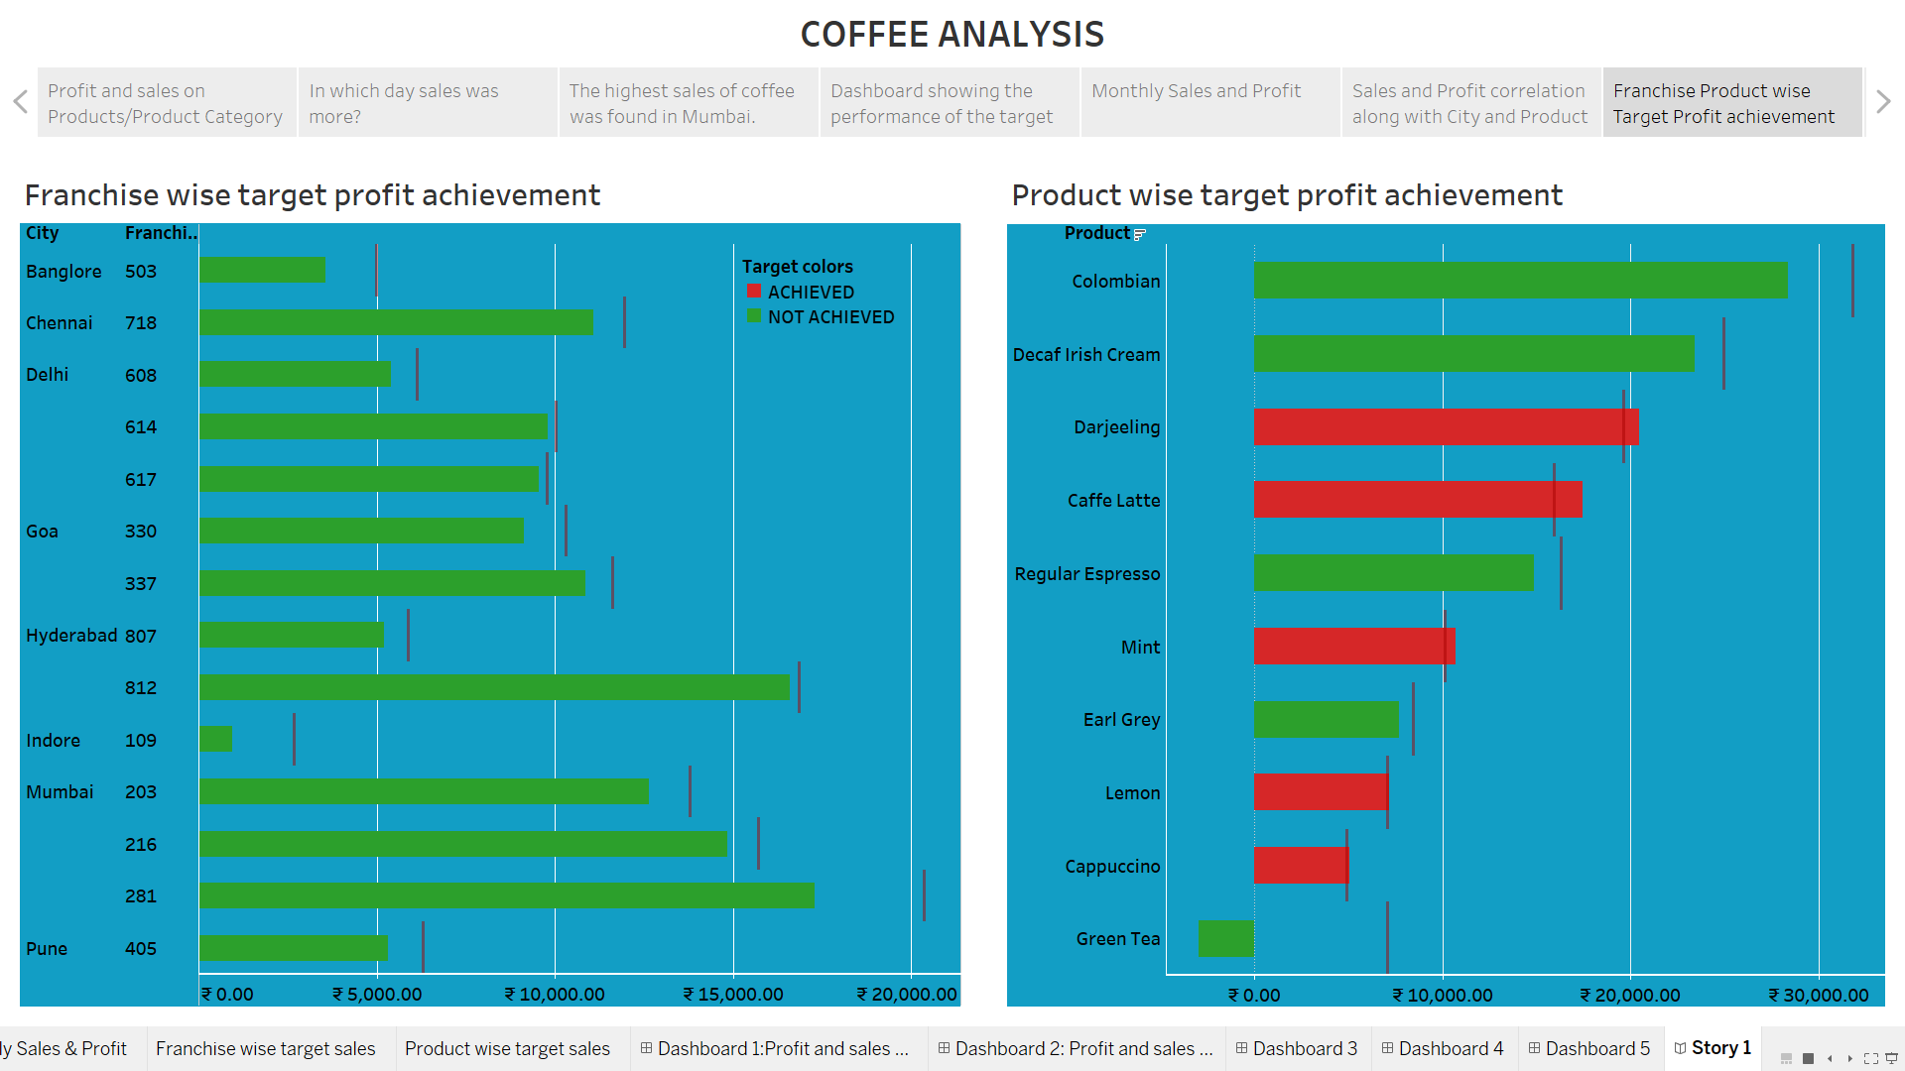

1. In Franchise wise Target Sales achievement and Product wise Target Sales achievement it was seen that the Sales target was achieved by any of the franchise.

